Question 1.

 |  |  |  |  | 5
 |  |  |  |  | 3
 |  |  |  |  | 2
 |  |  |  |  | 1
 |  |  |  | (0, | 0) |  |  | 1.5 | 2 |  | 3

According to graph, collision point is (3,2)

Question 2.

1)
2x + 4 = 6 → (1)
2x + 4y = 8 → (2)
Add these two equations (1) + (2)
4 + 4y = 14
4y = 10
10
y =
4

(1)

$$2x = 6-4$$

x = 1

y = 2.5

2)
$$3x + 14y = 4-2y-x$$
4x + 16y = 4 → (1)

3x + 6y + 2 = 11
3x + 6y = 9 → (2)
Equation (1) multiplie by 3 – Equation (2) multiplie by 4
(1)×3 (2) ×4
12x + 48y =12 12x + 24y = 36
Solve (1) and (2)
24y = 24
y = 1
From (1)
4x = 4
4x = 20
x = 5

3)
$2x+6y=9$→ (1)
$$y=\frac{7}{4} ,substitute to (1)$$
$$2x+6\left(\frac{7}{4}\right)=9$$
Simplify
$$x=-\frac{3}{4}$$

$x+9y=15$→ (2)
Equation (2) multiplied by 1
$2x+18y=30$→ (3)
$$Equation \left(3\right)-(1)$$
$$12y=21$$
$$y=\frac{7}{4}$$

4)
11x + 3y = 15 → (1)
$9y + 6x = 4-3x + 4y$ 5y + 9x = 4 → (2)

$$(1)×8 -(2)×3$$
$$55x+15y-15y-27x=75-12$$
$$28x=63$$
$$x=\frac{9}{4}$$

(1)$×$ 9 – (2)$×$ 11

$$99x + 27y-55y-99x = 135-44$$
28y = 91
91
y =
28
y = 3.25

Question 3.
1 a. Contribution per toy sold $= 16- (5+4+3) = 4\$$
b. Break-even in unit of output = Fixed costs / (Sales price per unit – Variable cost per unit)
$$=\frac{9000}{16-12}=2250$$

c.Break-even level of sales revenue = 2250 $×$ 16
= 36000$
2

36000

Break-even point

Total cost

Revenue
Margin of safety

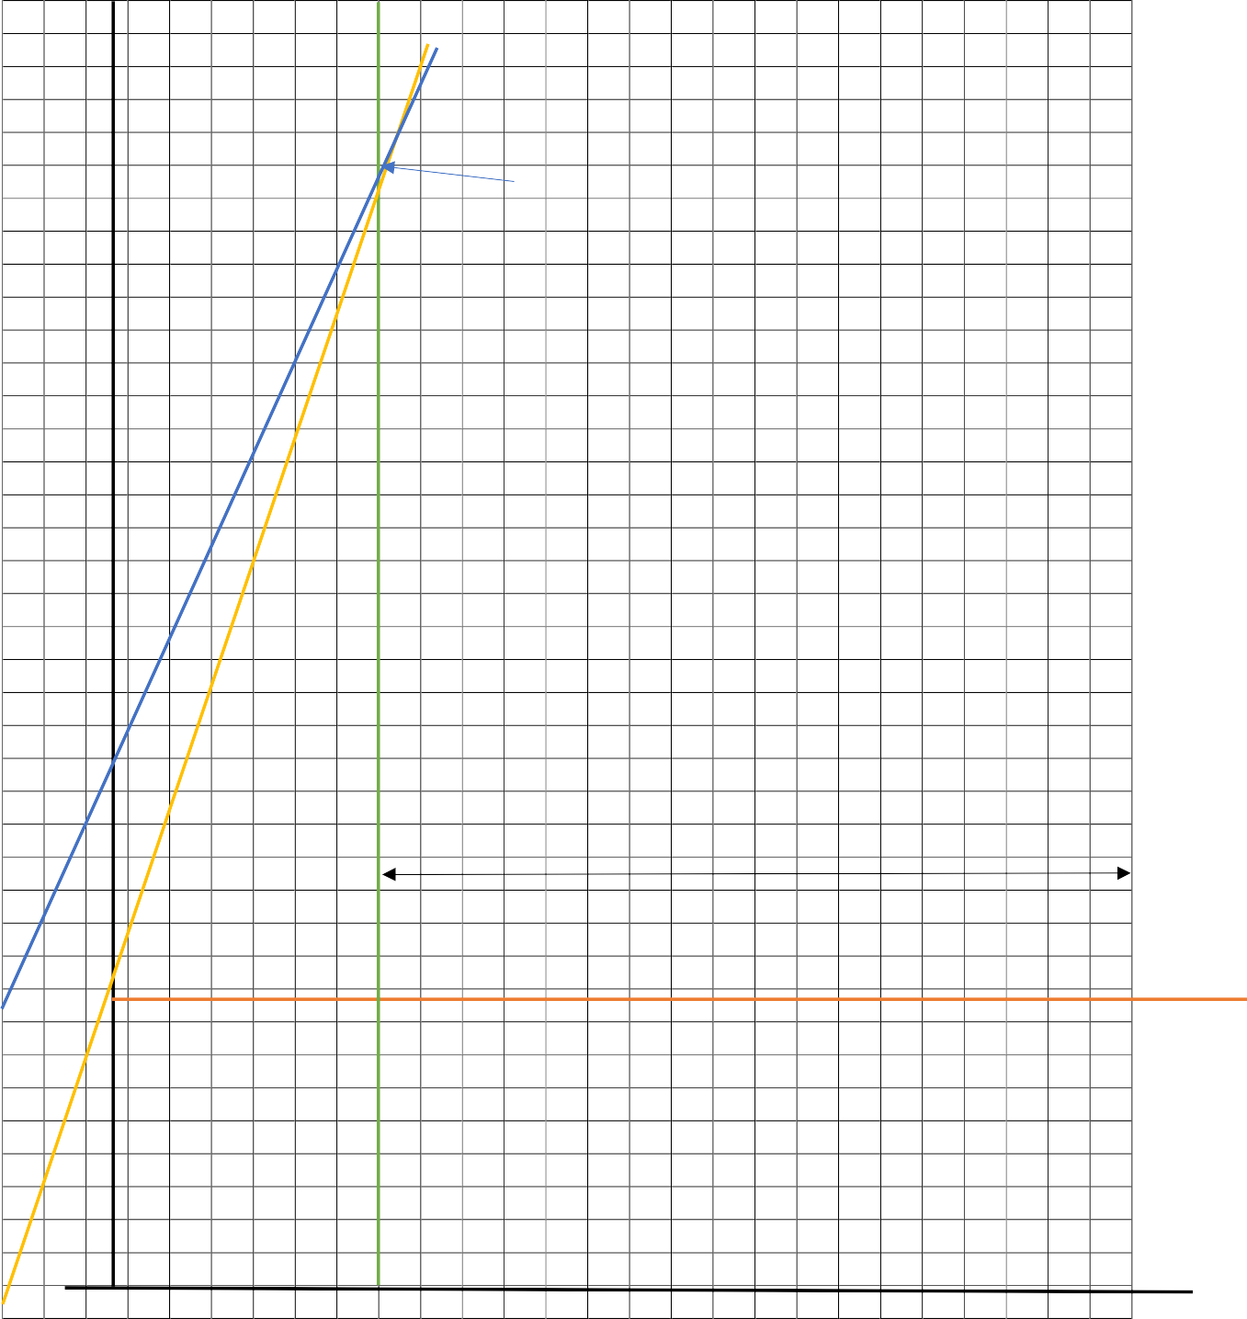

9000 Fixed cost

2250

- Write down the gradient and y-intercept from each of the following equations.
  - $y=5x+1$
  - $y=3-x$
$$c.y=10+9x$$

Equation | Gradient | Y intercept
Y=5x+1 | 5 | 1
Y=3-x | -1 | 3
y=10+9x | 9 | 10

Q5
- Draw the graph of these linear functions using a table of values.

- $y=0.5x$

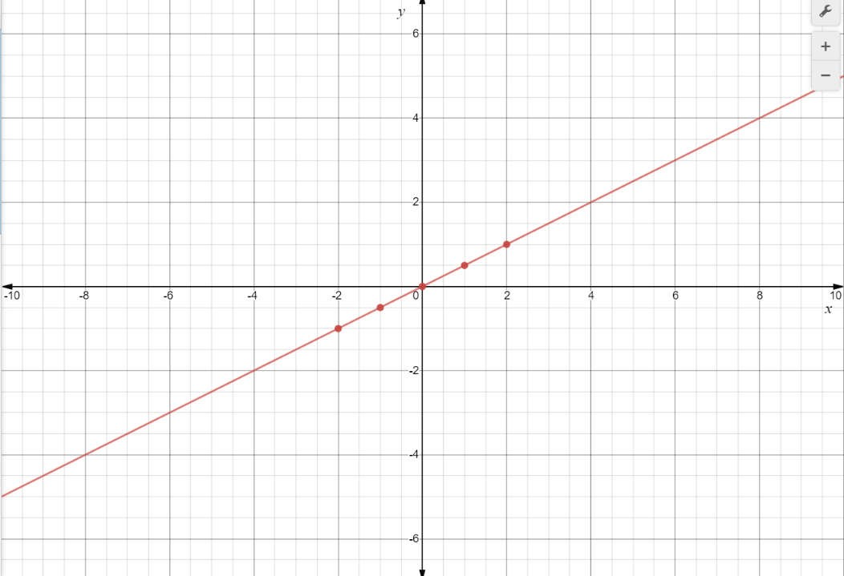

- $y= -3x-1$
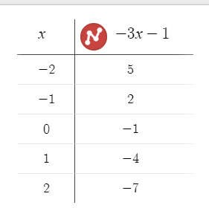
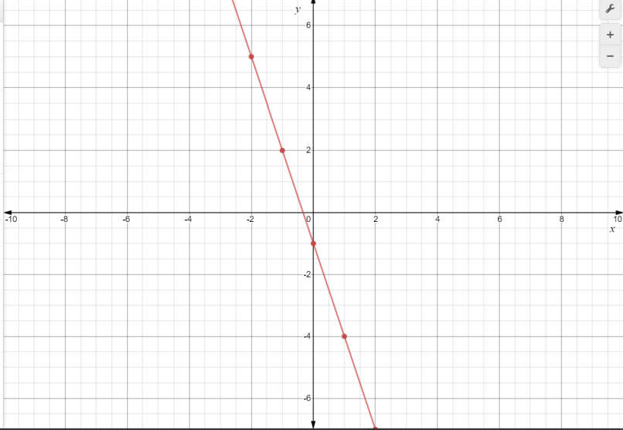

Q6
- A new piece of equipment is purchased by a business for $120 000. The value of the equipment (v in $1000) is depreciated each month (t) using the table below.
t | 0 | 8 | 16 | 24 | 32 | 40 | 48
v | 120 | 100 | 80 | 60 | 40 | 20 | 0

  - Plot the points from the table of values. Join the points to make a straight line.

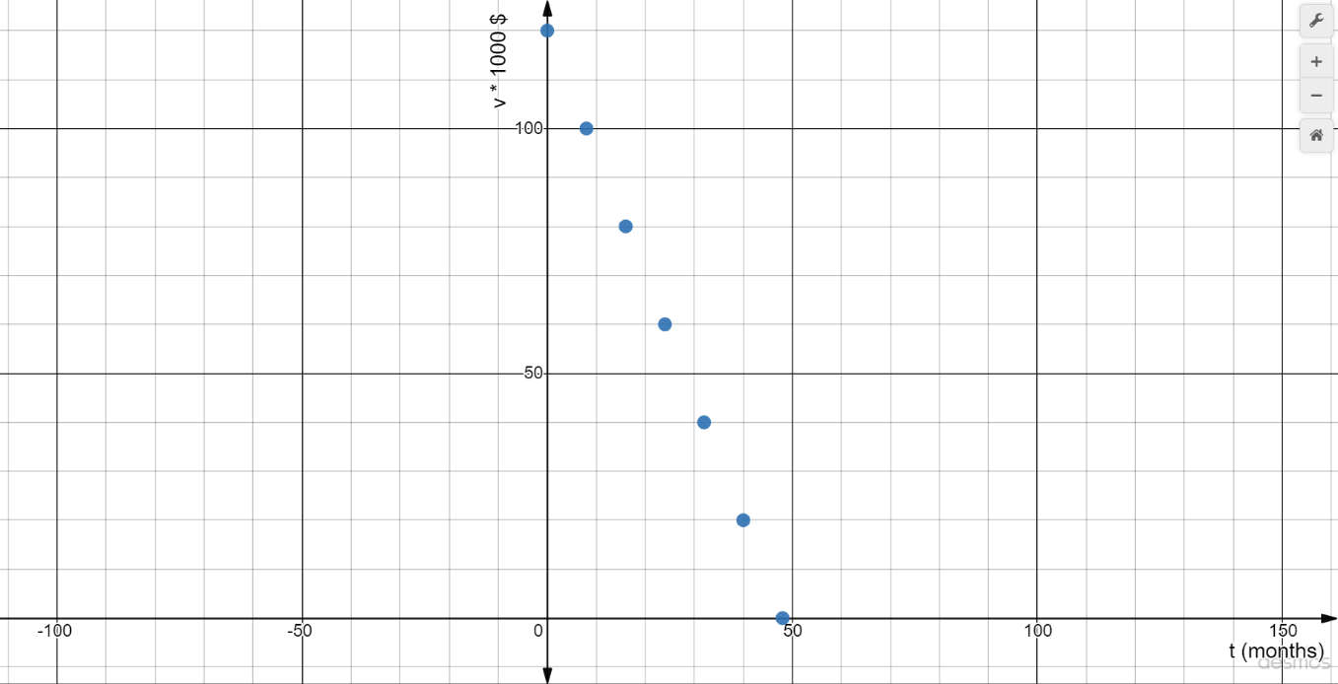

  - A linear model in the form y=nx+b describes this situation. What is the linear model using t and v?

n = (120–0) = 2.5
(0–48)

b= 120
Therefore,
y = 2.5x + 120; (y is measuring 1000 $)

  - When does the model predict the equipment will have no value?

No value means y= 0 $0= 2.5x – 120$
$$x=48$$
After 48 months equipment hasn’t valve.

  - Use the model to predict the value of the equipment after 2 months.

Putting, x= 2
y = 2.5(2)+ 120 = 115

Value of equipment = 115 000 $

  - When will the value of the equipment be $105 000?

Putting $y= 105$
$$105 = -2.5 x + 120$$
$$-15 = -2.5x$$
$$x = 6$$

When t is 6 moths.

  - Use the model to predict the value of the equipment after 56 months. Can this happened? Explain your answer

$$Putting x= 56$$
$$Y= -2.5×56 + 120$$
$$Y = -20$$
That means, Value of the equipment is -20 000$. That cannot be happen, because the money cannot be negative. After the valve became zero at 48 moths, equipmentconsider as zero valve Equipment furthermore.

Q7

- Michael has a container filled with 10 litres of water. However, the container has a small hole in the base and is leaking at a rate of 0.25 litres per minute.

  - Write a linear equation in the form V=nt+b to describe this situation.

Let; time (t) measure in minutes
Volume that remains in the container (V) measure in litters m= -0.25
Then we can write it as; V= -0.25t + b

at t=0, V= 10 Therefore b=10
V= -0.25t + 10

  - What volume of water remains after 90 seconds?

$$`t=\frac{90}{60} =1.5$$
$$V= -0.25×1.5 +10$$
$$Vat t = 1.5 =9.625 litters$$
  - How long would it take for all the water to leak out?

Put the value for V=0 $0= -0.25t +10$
$$10=0.25t t= 10/0.25$$
$$t=40 minutes$$

Q8
- Draw the graph of these linear functions using a table of values.
y=0.5x y= 3x-1

Same as Q5

